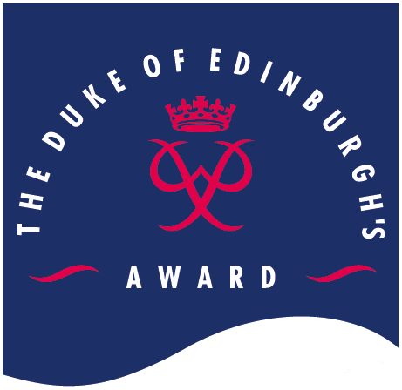
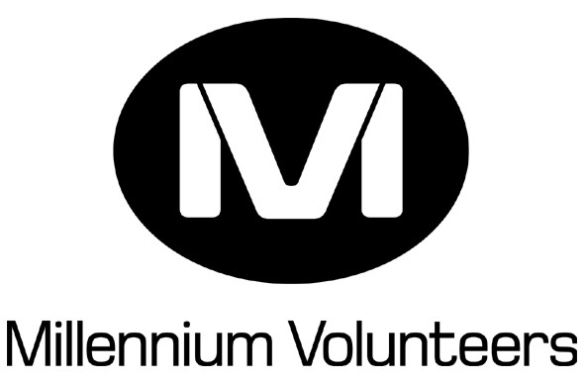 The Duke of Edinburgh’s Award MV
Award Claim

IMPORTANT
Please ensure that this form is fully completed and signed. Please use block capitals, as any information given will appear on your certificate(s).

Surname
First Name(s)
Address
Postcode | Total number of hours completed

Volunteering start date / / . Volunteering end date / / .

Volunteering completed with . (Enter name of group, squadron, guide unit etc)

Millennium Volunteer Declaration

I confirm that I have completed the required number of hours and that I am applying for my
100 hour certificate 200 hour Award (tick as appropriate)

MV signature: _________________________

You can now be awarded 500 points on your Connexions card for each 100 hours of MV volunteering completed up to a maximum of 1000 in 1 year. If you hold a connexions card please put the number here so that the points gained by achieving your MV awards can be added onto your card.
.

MV Advisor Declaration

I can confirm that . has completed the required number of volunteering hours and is eligible for their 100 hour certificate 200 hour Award (tick as appropriate)

MV Advisor signature: ______________________

Please return this form to:

The completed and authorised form should be sent to

If you have any queries on how to fill this form in please contact the MV coordinator on

REGION: For Regional use only
Received by . Date / / .
Date forwarded to HO / / .

The Duke Of Edinburgh's Award MV

Project Profile

IMPORTANT
These questions must be answered before you can receive your certificate or Award.

Which projects did you volunteer with and what activities were you involved with?
Because of your volunteering what was the biggest benefit to others in your project/ community?
What do you feel you have learnt from being involved as an MV and what was the best part of your MV project?
Is there anything you wish you had done differently in your MV project? Is there anything that would have made it better?
How long did it take you to complete your 100 hour certificate?
0 – 3 months 3 – 6 months 6 – 9 months 9 – 12 months

If applicable how long did it you to complete your 200 hour Award?
0 – 3 months 3 – 6 months 6 – 9 months 9 – 12 months

Will you continue volunteering in the future?
Yes No Don’t know

Are you currently doing a Duke of Edinburgh’s Award?
Bronze Silver Gold No

What Duke of Edinburgh’s Awards (if any) have you finished? (tick all completed)
Bronze Silver Gold No

