The Duke of Edinburgh’s Award MV
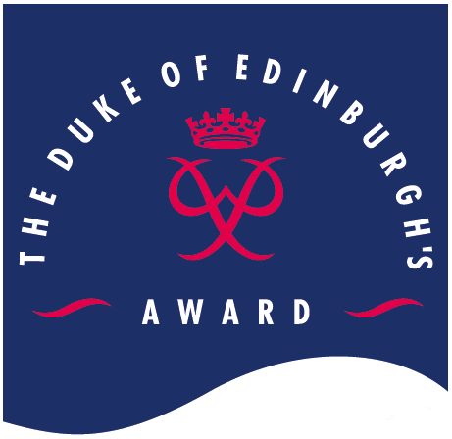
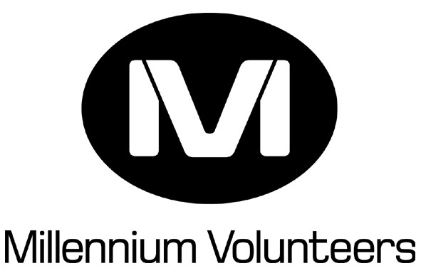 Registration Form

IMPORTANT
Please ensure the remainder of this form is completed. You must not begin your placement until this form has been completed and signed.
Please use block capitals

Surname
First Name(s)
Address
Postcode

Telephone No . E-mail .
Date of Birth / / . Gender Male/ Female (delete as applicable)
Date Volunteer plan agreed___ / ___ / _ __
- Please tick here if you have already received an MV Record Book

MV signature: _________________________ MV Advisor signature: ______________________

Award Group/ Squadron/ Cadet Unit .

You can now be awarded 500 points on your Connexions card for each 100 hours of MV volunteering completed up to a maximum of 1000 in 1 year. If you hold a connexions card please put the number here so that the points gained by achieving your MV awards can be added onto your card.

I do not have a connexions card & I would like some more information about the Connexions card Yes/ No (delete as appropriate)

Please return this form to:

The completed and authorised form should be sent to

If you have any queries on how to fill this form in please contact the MV coordinator on

REGION: For Regional use only
Received by . Date / / .
Date forwarded to HO / / .
- Do you have a disability or health problem that may affect your experience as an MV?
(yes/ no) (delete as applicable)

If yes, please give details of ways in which we can help improve your experience as an MV.
.
.

- To help us assess the success of our equal opportunities policy, please indicate which of the following ethnic groups you belong to:

Asian or Asian British | Indian |  |  | Mixed | White & Black Caribbean
 | Pakistani |  |  |  | White & Black African
 | Bangladeshi |  |  |  | White & Asian
Black or Black British | Caribbean |  |  | White | British
 | African |  |  |  | Irish
 | Any other |  |  |  | Any other
Chinese | Chinese |  |  | Other

- Please indicate your employment status: (tick one only)
◻ Employed – full time ◻ On a government training programme
◻ Employed – part time ◻ Self-employed
◻ In further Education ◻ Unable to work (long term sickness or disability)
◻ In Higher Education ◻ Unemployed and not seeking work
◻ In other training ◻ Unemployed and seeking work
◻ In school ◻ Other (please specify): .

- Please indicate how you heard about MV (please tick only one box):
◻ Advertising in press ◻ Church, Temple etc
◻ Advertising on radio ◻ School/ College
◻ Award Entrance Pack ◻ Friend
◻ Award Journal magazine ◻ Youth Service
◻ www.theaward.org ◻ Inside Out Magazine
◻ Connexions ◻ Other (please specify) .

- Have you been a volunteer before? yes/no (delete as applicable)
If ‘Yes’ was it with another MV Project? yes/no (please give details)
.

- Do you hold any of the following qualifications?
◻ GCSE, Standard or NVQ/SVQ Level 2
◻ A-Level, Scottish Highers or NVQ/SVQ Level 3
◻ Degree, or NVQ/ SVQ Level 4/5
◻ Other (please specify) .

- Are you involved with The Duke of Edinburgh’s Award yes/no (please mark as appropriate)
◻ Bronze Participant ◻ Silver Participant
◻ Gold Participant ◻ Leader/helper/mentor etc
◻ Other (please specify): .

- Name of Award Leader or MV Supervisor .

- Emergency Contact details (please give name, contact number and address)
.

